**PERSISTENT SYSTEMS**



**REPORT ON**

**PAY FOR PERFORMANCE**

**UNDER THE GUIDANCE OF**

SHRIRAM NATRAJAN, ANAGHA VYAS, RAJEEV DAITHANKAR, SHIRISH JOSHI

**SUBMITTED BY**

ARYA VENKATAGIRI, MRUGANK SALUNKE,

SHALABH SINGH, ABHISHEK KAKALIS

**1. INTRODUCTION**

Linking quality to payment has been an important reform in the health care industry. Value based reimbursement models presses the need for hospitals and physicians to work towards a mission to improve the health of the population as a whole, by providing quality care, improving efficiency and lowering the overall healthcare.

There are two revenue models that are in use to generate revenue in the health care sector, Fee for Service and Pay for Performance. While the former has been around for a relatively longer time, the latter is a better way forward towards achieving population health management.

Fee for Service- The predominant fee for service model pays the providers in terms of the services and the complexity of the services rendered. In some cases health care providers maximize their revenue by providing the patient a host of services that might not actually be required. Hence in this process the patient’s health outcome is often overlooked.

Pay for Performance- In this model, the revenue generated is linked to the health outcome of the patient. Providers of health care who meet the predefined quality and performance measures are offered financial rewards in terms of annual bonuses.

**1.1 BACKGROUND**

The percentage of economy invested in healthcare increases every year but this does not necessarily translate into better health outcomes.  According to the latest OECD health statistics, the United States spends 16.4 percent of GDP on healthcare -- almost twice the OECD average of 8.9 percent.  In per capita health spending, the United States fares even worse, spending $8,713 per capita, or more than 2.5 times the OECD average.[1]

Compare to the various developed nations, US has been relative ranked lower in terms of quality, access, efficiency, equity and health outcomes.

There is still a significant part of the population that is uninsured due to high health care. High health costs, fragmented and poor delivery, among the various providers required a revision in the reimbursement model.

**1.2 SHIFT IN THE MODEL**

The transition from a fee for service to a pay for performance is one that will take many years to perfect. It is very unlikely that a hospital can be categorized into either of the model at present. The main issue lies in incorporating the pay for performance model into the fee for service environment. When performance of the hospitals required to be tracked, the challenge becomes cumbersome. A sophisticated system is required to be in place across all healthcare providers in order for them to track their financial and quality performance all through the year. Tracking the above mentioned metrics will help them estimate if they are going to be charged a penalty or not. It would also help them identify where an improvement needs to be made in their delivery.

Process, outcome, cost and patient statistics measures need to be defined and checked routinely.

Despite the difficult process the pay for performance model has many advantages. It strives towards bettering the health of the patient by increasing physician engagement and allow for financial savings.

**1.3 COMPONENTS OF THE VALUE BASED SYSTEM**

There are many programs under the value based purchasing system. These programs are designed to provide incentives, levy penalties and track the quality of care delivered by the hospitals.

**Hospital Readmission Reduction program**- This programs is mainly focused on high volume or high cost processes such as heart attack, pneumonia, acute myocardial infraction. The law under the Affordable Care Act enables Medicare to reduce its reimbursements or payments to hospitals that depict excess readmission that are paid under the CMS inpatient prospective payment system (IPPS).

Hence this programs would incentivize physicians and doctors to provide high quality care and what’s best for the patient right from the start.

**Hospital Value Based Purchasing Program**- This programs affect the payments related to the inpatient stays. In this program, hospitals are compared with one another on a set of parameters and how well they have improved over the years on each measure with respect to themselves.

The goal of this program is to improve the clinical outcomes and improve the experience of the patient during their stay at the hospital.

**Hospital Acquired Conditions reduction Program**- This program is designed to improve patient safety and reduce incidents of complications that could be acquired by the patient during their stay in the hospital. A total HAC score is computed for each hospital based on the risk adjusted quality measures.

**2. PROBLEM STATEMENT**

The problem statement initially concentrated on comparing the pay for performance model and the fee for service model, year wise.

1. During the literature review, it was difficult to classify the hospitals working under either of the particular models exclusively.
2. Since the FFS model attains revenue by charging the patient for the procedures carried out during the treatment, the P4P model links payment to quality. Hence defining parameters or comparing quality outcomes was difficult.
3. Besides, the pay for performance model in the health sector is a recent reform and it still in its budding stages.

After a brief meeting with Dr. Sawad, our problem statement aimed at studying the transition of this model over the course of three years. The readmission ratio parameter was chosen as the main metric to notice trends over the years. The HRRP applies to conditions such as pneumonia, heart failure and acute myocardial infraction.

Chronic obstructive pulmonary disease (COPD), Elective total hip arthroplasty (THA) and Total knee arthroplasty (TKA) were taken into account from the fiscal year, 2015.If a patient returns to the hospital with the same problem within a period of 30 days, it is treated as a readmission.

Our project intends on highlighting the following points over the years (2013-2015):

* Trend of the readmission ratios in pneumonia, heart failure and acute myocardial infraction over the years.
* Effect of the readmission ratio with respect to the hospital size.
* Effect of imagining efficiency over the years in order to depict if the system has become more transparent or not.
* Effect of readmission ratio with socio economic status. Poor socio economic factors such as poverty, low literacy levels, unemployment and poor living conditions could have significant impact on the readmission ratios.

A few studies indicate that unemployment could contribute to 18% of the readmission ratio and about 6% could be contributed by poverty. In some places, the race of the people could also an indicator of the increasing readmission. Chances of a black person being readmitted is almost 15% higher than that of a white patient. For hospitals in these areas that continually provide quality service but are still charged a penalty due to functioning is in a disadvantaged environment, could be unfair. Hospitals that are unable to maintain the threshold in readmissions, are levied a penalty. The Medicare reimbursement has been docked up to 3% in the fiscal year of 2015.

**3. TOOLS AND ENIVRONMENT USED**

The various tools used during the course of our project are mentioned below.

1. Excel- Excel was used for primitive data analysis such as sorting, filtering, conditional formatting, pivot tables, summary tables and transforming. Simple deletion techniques were performed on excel if feasible.
2. MySQL- MySQL is a database that supports the use of Structured Query Language to access data. This software was primarily used to merge and create new tables in order to make one coherent data sheet.
3. Python- Python is a high level dynamic programming language. It is a popular choice of data language used by many data scientist. Python was used in our project to performing higher levels of filtering data that could not be carried out in excel.
4. Rattle- Rattle is a graphical interface to R. It supports basic data management tasks, as well as a number of different modeling functions. We used rattle to perform exploratory data analysis. We examined various co-relations and performed box plot and summary charts.
5. Tableau- [Tableau](http://www.tableau.com/) is a data visualization tool which was used by us to depict various trends, bar plots, pie charts and a map plots. Tableau is an easy for most beginners as we could perform various visualizations without the need for any programming.
6. Share insights- Share insights is a unique platform that allows organizations to analyze an overlay of enterprise data with public or cloud sources to derive meaningful insights. Since it’s a platform developed by persistent, this was out prime platform used for visualization.

**4. DATA CLEANING**

The majority of data has been acquired from data.medicare.gov and dartmouthatlas.org. The flat files obtained from the CMS website are updated yearly.

Relevant files:

1. Hospital_Data

Attributes – Provider Number, Hospital Name, City, County, State

1. Hospital_Bed_Revenue

Attributes – Hospital Name, City, Staffed Beds, Gross Patient Revenue, Total Discharge, Patient Days

1. Readmission_PUF 2013/14/15

Attributes – Provider ID, FY 2013 Readmission Payment Adjustment Factor, Number of Pneumonia Cases, Excess Readmission Ratio for Pneumonia, Number of Heart Failure Cases, Excess Readmission Ratio for Heart Failure, Number of Acute Myocardial Infarction Cases, Acute Myocardial Infarction Excess Readmission Ratio

1. Socio ecconomic

Attributes – State, City, County, Race, Age 65 to 84, Age 85 plus, Education, Population, Poverty, Median Household Income

1. Image efficiency (2013/14/15)

Attributes –

a) Outpatients with low back pain who had an MRI without trying recommended treatments first such as physical therapy

b) Outpatients who had a follow-up mammogram or ultrasound within 45 days after a screening mammogram

c) Outpatient CT scans of the abdomen that were “combination” (double) scans

d) Outpatient CT scans of the chest that were “combination” (double) scans

e) Outpatients who got cardiac imaging stress tests before low-risk outpatient surgery

f) Outpatients with brain CT scans who got a sinus CT scan at the same time

**Flow:**

1. Inner Join – Hospital_Data and Hospital beds revenue. Primary Key (Hospital_Name, City)

Output – Hospital_hbr

Class attribute added.

|  |  |
| --- | --- |
| Staffed beds | Class |
| 0-99 | A |
| 100-199 | B |
| 200-299 | C |
| 300-399 | D |
| 400-499 | E |
| 500+ | F |

1. Inner Join – Hospital_hbr and Readmission_PUF (2013/14/15). Primary Key (Provider ID)

Output – Hospital_hbr_readmission_2013(14/15)

1. Attribute “Readmission Payment Adjustment Factor” converted to “Penalty” with the condition if value <1 = ‘Yes’ else ‘No’
2. Inner Join - Hospital_hbr_Readmission_2013(14/15) and County_GDP. Primary Key (County, State)
3. Inner Join – Hospital_hbr_Readmission_county_2013 and Hospital_hbr_Readmission_county_2014 and Hospital_hbr_Readmission_county_2015

Primary Key (Provider ID)

Output – all_2013_2014_2015

1. Inner Join – Image_efficiency_2013 and Image_efficiency_2014 and Image_efficiency_2015. Primary Key (Provider ID)

Output – Image_efficiency_all

1. Inner Join – Education and Unemployment and demographics. Primary Key (State, County)

Output – edu_unemploy_demo

1. Inner Join – all_2013_2014_2015 and edu_unemploy_demo. Primary key (State, County)

Output – all_2013_2014_2015_edu_unemploy_demo

All missing data has been either removed by deleting the particular row or replaced by average/median.

**5. EXPLORATORY ANALYSIS**

**5.1 SUMMARY CHART OF SOCIO ECONOMIC FACTORS**

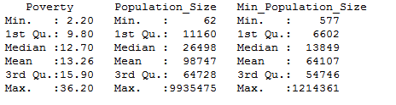

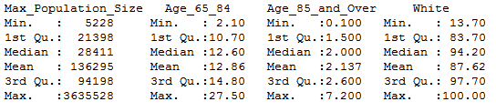

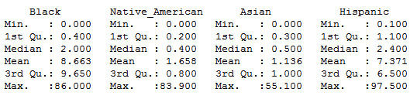

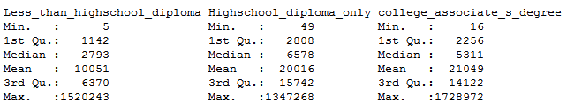

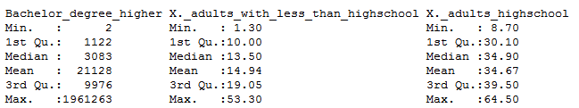

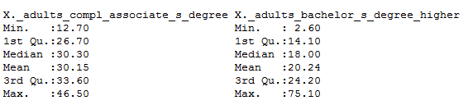

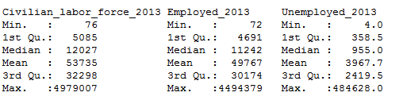

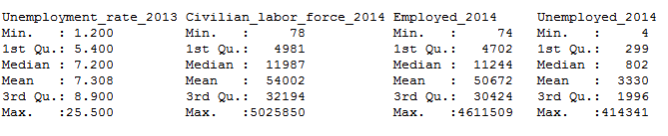

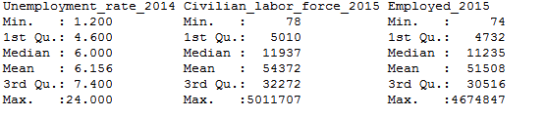

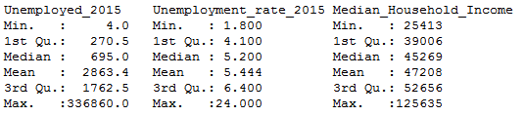

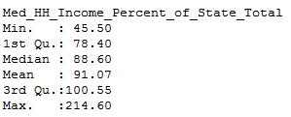

**5.2 CORRELATIONS BETWEEN EACH RACE AND VARIOUS OTHER SOCIO ECONOMIC FACTORS**

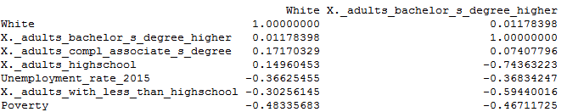

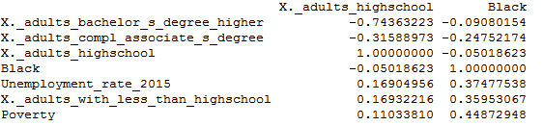

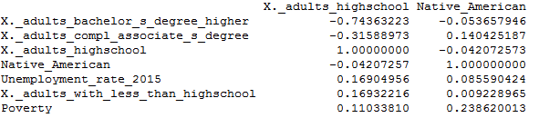

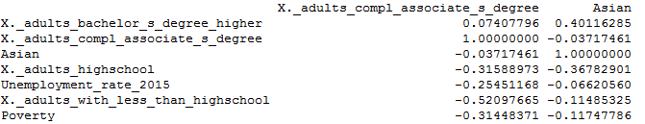

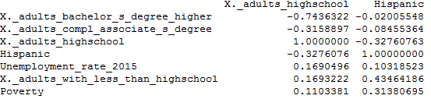

**5.3 CORRELATIONS ON CONDITIONS (Pneumonia, Heart Failure and Acute Myocardial Infraction)**

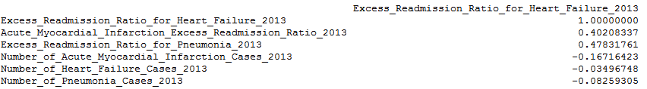

**5.4 CORRELATION BETWEEN RACE AND VARIOUS READMISSION RATIOS**

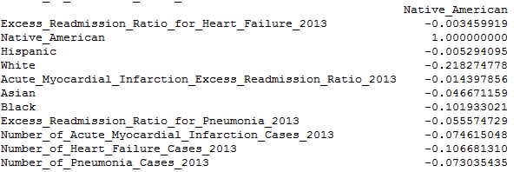

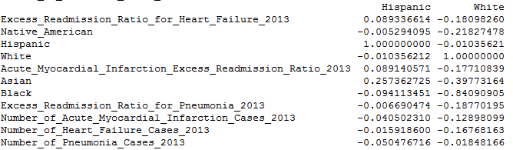

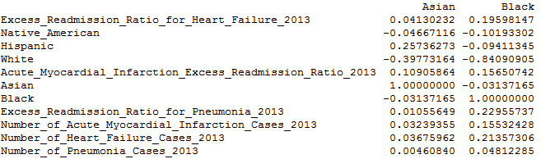

Correlation Observations

* The correlation between each race and different socio economic factors are low in magnitude. Blacks, Native American and Hispanic indicate a positive correlation with respect to unemployment rate, poverty and low education levels. Whites and Asian indicate positive correlation towards higher levels of education and display a negative correlation between unemployment rate, poverty and education levels.
* Heart failure depicts a positive correlation with respect to acute myocardial infraction and Pneumonia. In most cases, the no of cases for a particular condition and its readmission ratio, show an extremely small negative correlation except for pneumonia that shows a very small positive correlation with the readmission ratio.
* Blacks and Asians show a slight positive correlation with respect to the number of cases of pneumonia, heart failure and acute myocardial infraction, while the other races depict negative correlation.

**6. CODES**

All of the necessary codes have been upload on the GitHub.

**7. RESULTS**

The following are the graphs depicted on share insights

State -1 Texas

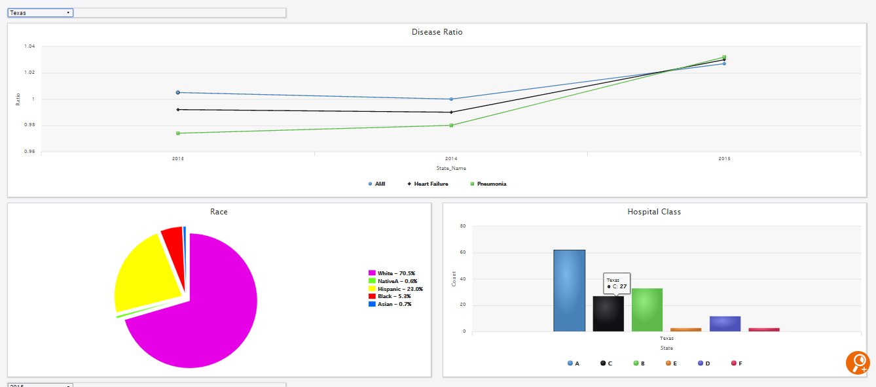

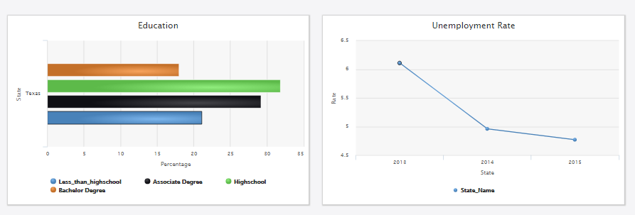

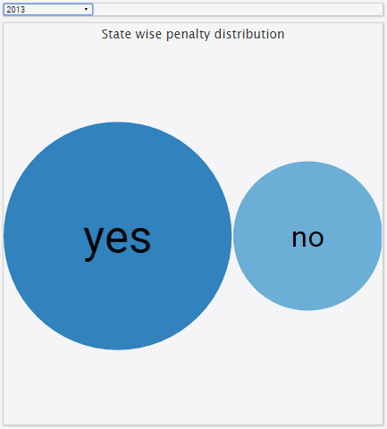 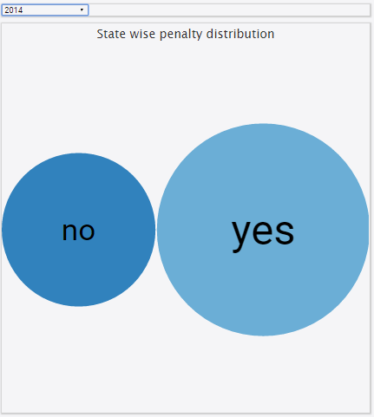 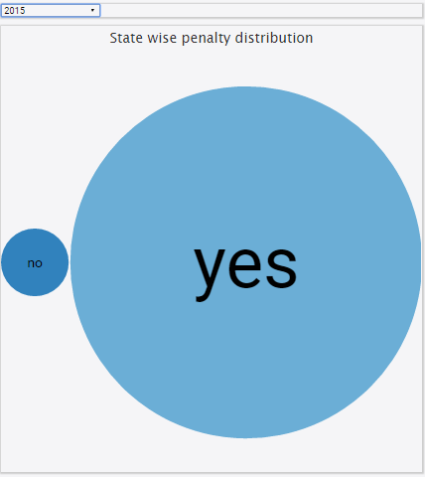

2013 2014 2015

Expected-

* Readmission ratios would increase for poor socio economic environments.
* The size of the hospital to affect the readmission ratios. Smaller hospitals would react faster to the change in the reforms as they cannot afford the penalty or reduced reimbursement.
* Race was expected to affect the readmissions ratio.
* Decrease in unemployment rate would show a decrease in the readmission ratios.
* As readmission ratios increase we notice that the number of hospitals being penalized also increases.

Observed-

* Readmission ratios increased.
* Unemployment rate has decreased over the period
* Education levels are high.
* Predominately white. Hispanics are the second highest.
* No.of hospitals penalized increased

Inference-

* Race cannot be directly correlated with readmission ratios. It does not have a significant impact.
* Although unemployment rate has decreased, it may not reflect on the readmission ratios immediately.
* Class A hospitals are more in number in the state of Texas. But despite that, the readmission ratios have increased.

State 2- NEW YORK

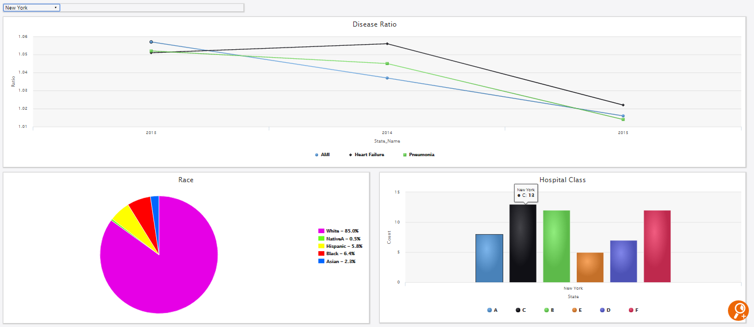

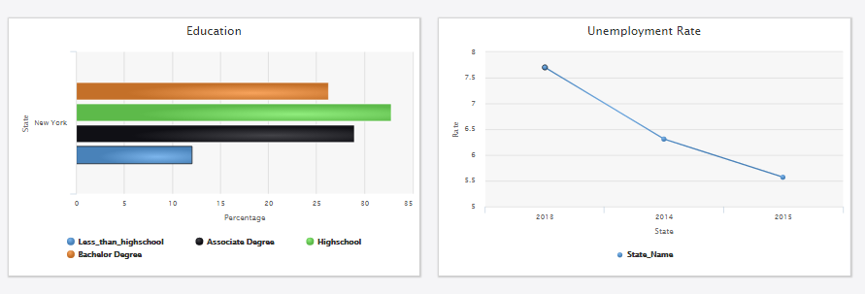

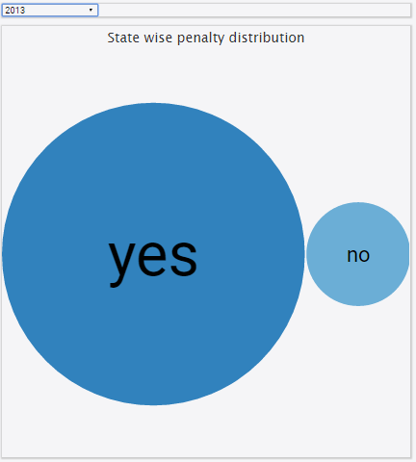 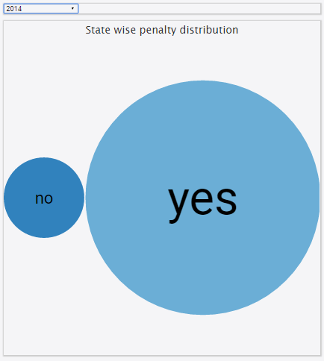 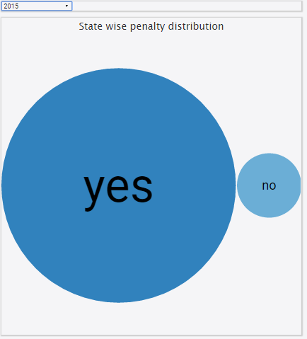

2013 2014 2015

Expected-

* Readmission ratios would decrease for rich socio economic environments.
* The size of the hospital to affect the readmission ratios. Smaller hospitals would react faster to the change in the reforms as they cannot afford the penalty or reduced reimbursement.
* Race was expected to affect the readmissions ratio.
* Decrease in unemployment rate would show a decrease in the readmission ratios.
* As readmission ratios increase we notice that the number of hospitals being penalized also increases.

Observed-

* Readmission ratios decreased.
* Unemployment rate has decreased over the period
* Education levels are high.
* Predominately white. Hispanics are the second highest.
* No.of hospitals penalized increased.

Inference-

* Compared to Texas, the population of White is higher. This may show a basic correlation between race and readmission for state of New York.
* Although unemployment rate has decreased, it may not reflect on the readmission ratios immediately and can reflect in future years.
* There is a healthy mix of all classes of hospitals. A higher number of F Class hospital may show that the bigger hospitals have more monetary power to bring reforms for readmission.

**Image Efficiency**:

AMI

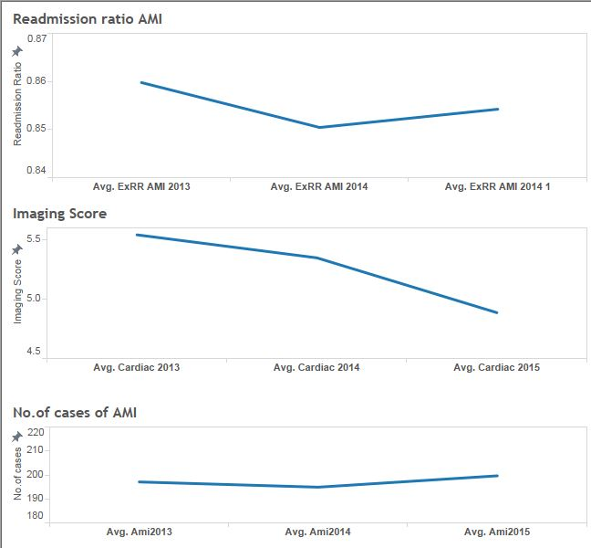

Pneumonia :

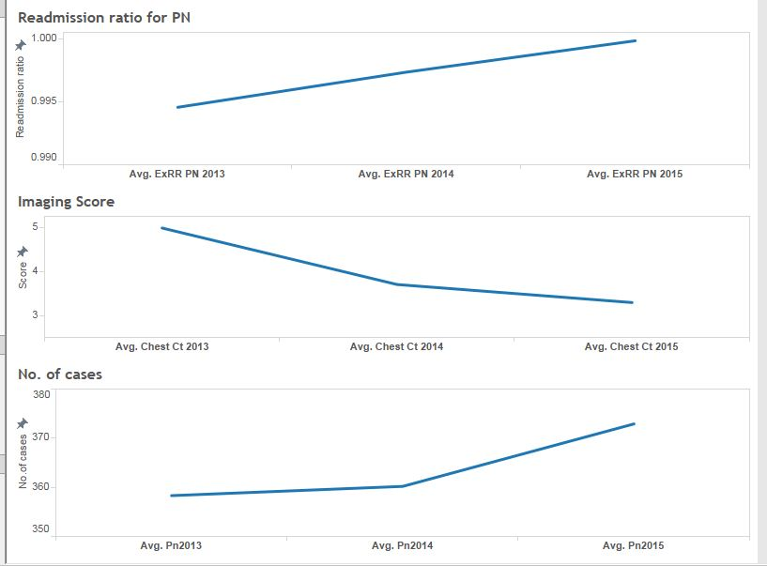

Expected:

* The pay for performance would bring transparency in use of imaging machinery for complex procedure like AMI and Pneumonia.
* The imaging efficiency to increase over a span of 3 years.

Observation:

* Imaging efficiency for the country has over all increased despite the readmission ratios and number of cases increasing.

Inference:

* System is more transparent with the new payment model.